**Basic Programming Practicum Experiment Jobsheet 4**



**From:**

AL AZHAR RIZQI RIFA’I FIRDAUS

**Class:**

1 I

**Absence:**

01

**Major:**

Information Technology

**Study Program:**

Informatic Engineering

Experiment 1

1. Observe the flowchart!

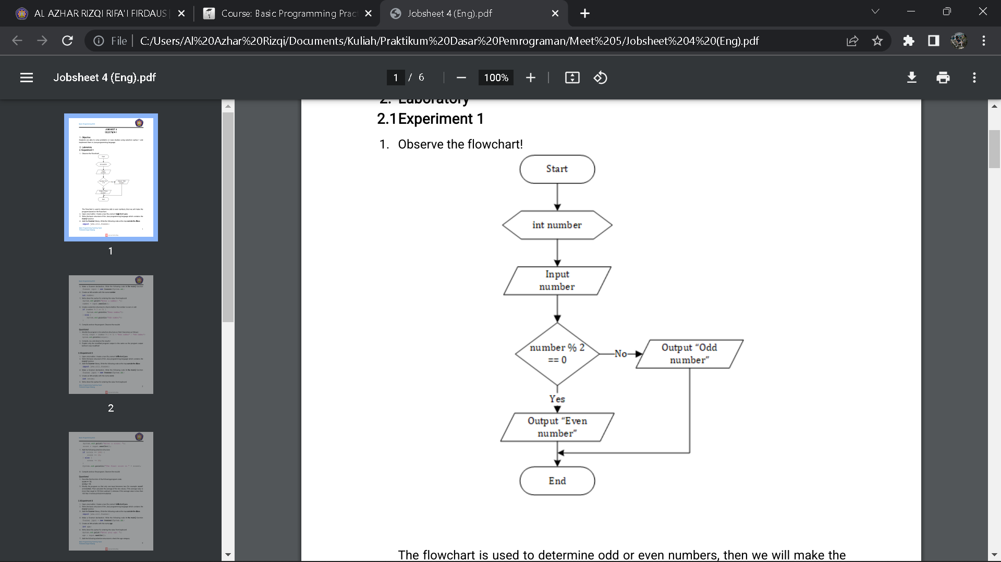

The flowchart is used to determine odd or even numbers, then we will maketheprogram based on the flowchart.

1. Open a text editor. Create a new file, name it Selection1.java

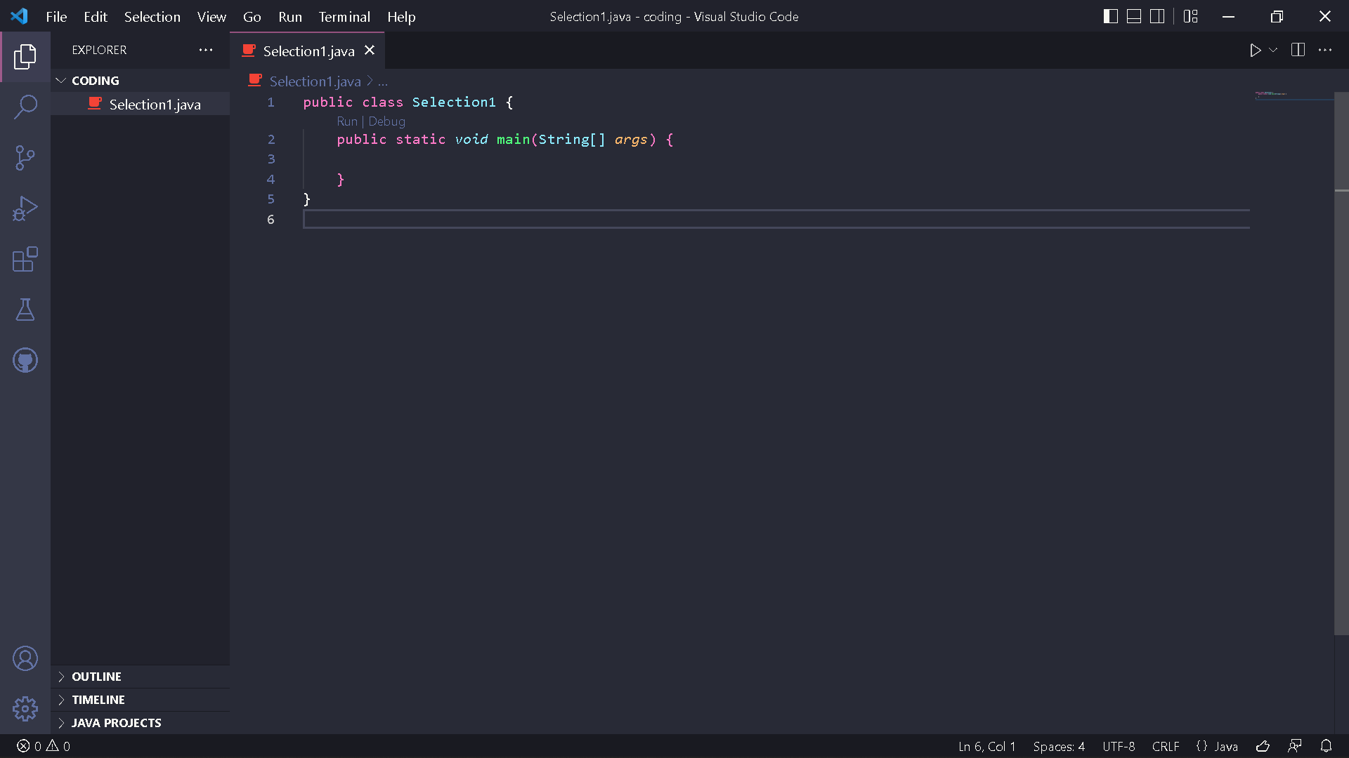

1. Write the basic structure of the Java programming language which contains the main() function



1. Add the Scanner library. Write the following code at the top outside the class

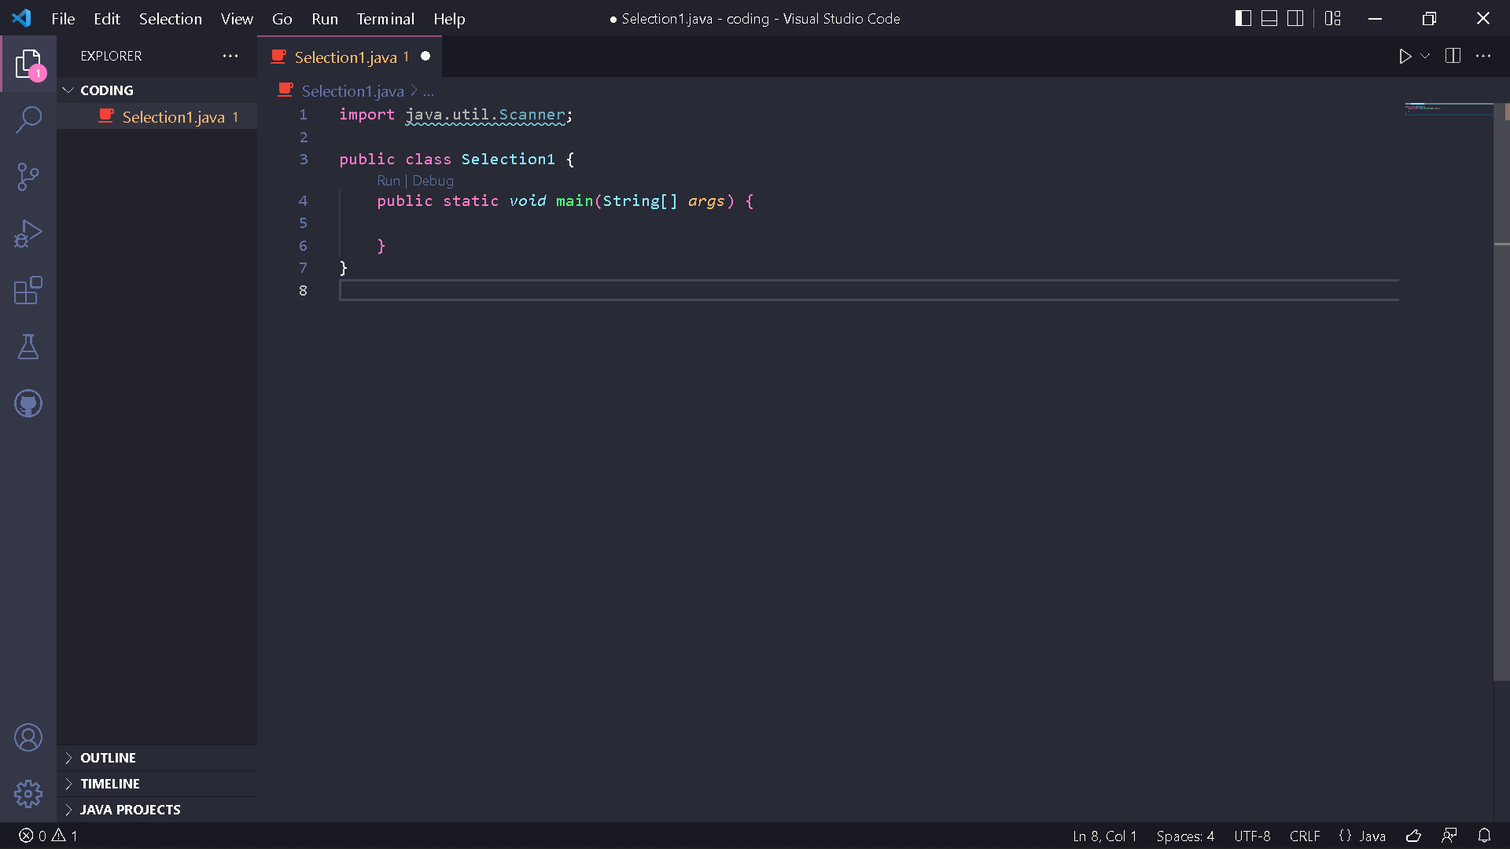

1. Make a Scanner declaration. Write the following code in the main() function

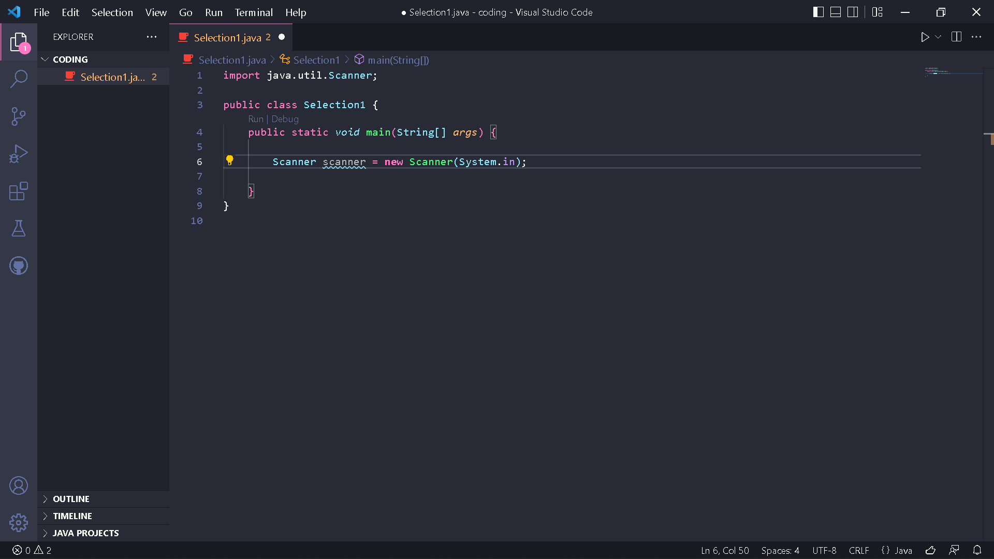

1. Create an int variable with the name number

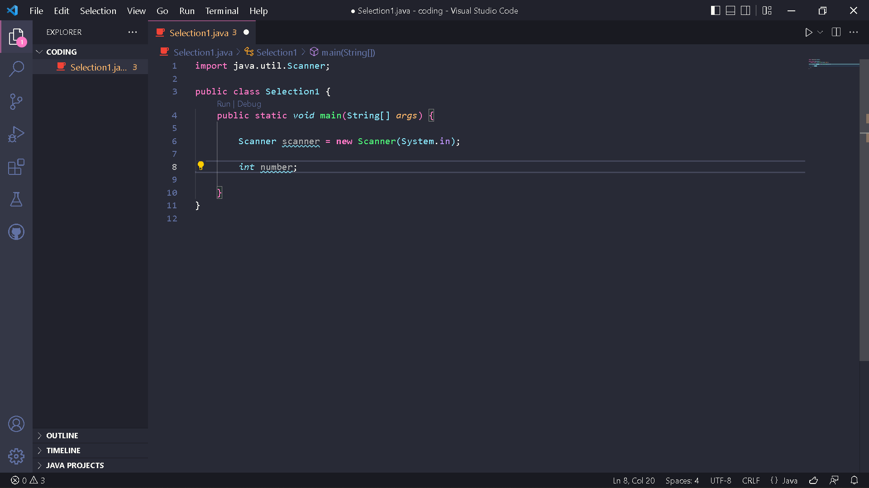

1. Write down the syntax for entering the value from keyboard

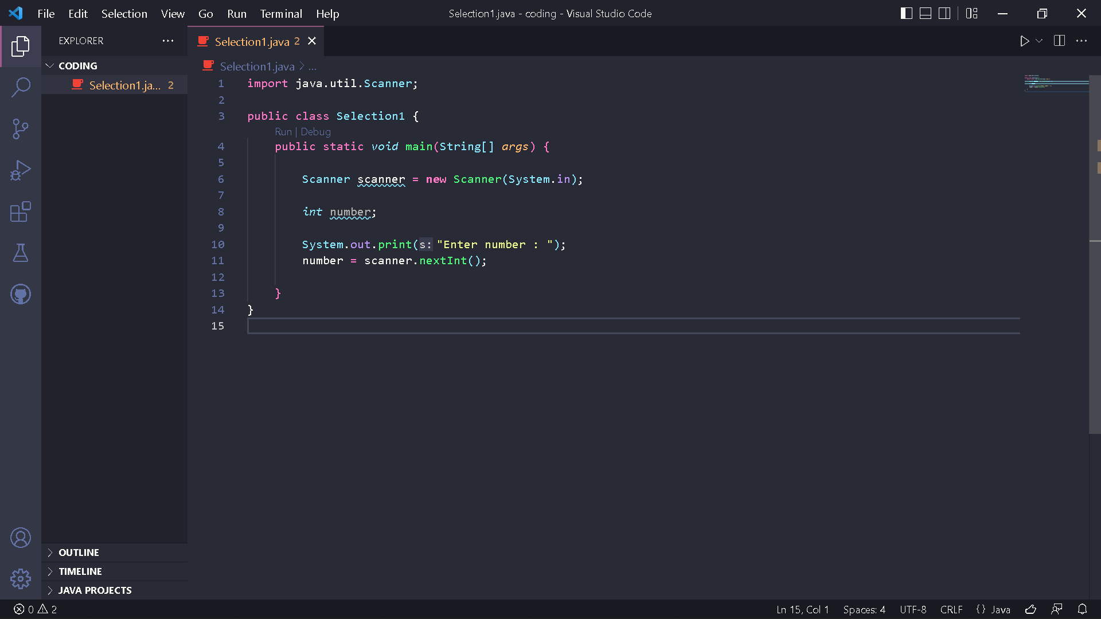

1. Create a selection structure to check whether the number is even or odd

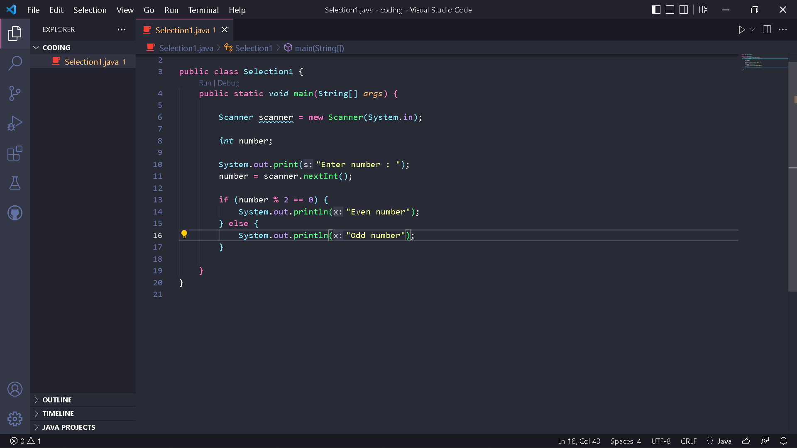

1. Compile and run the program. Observe the results!

Code :

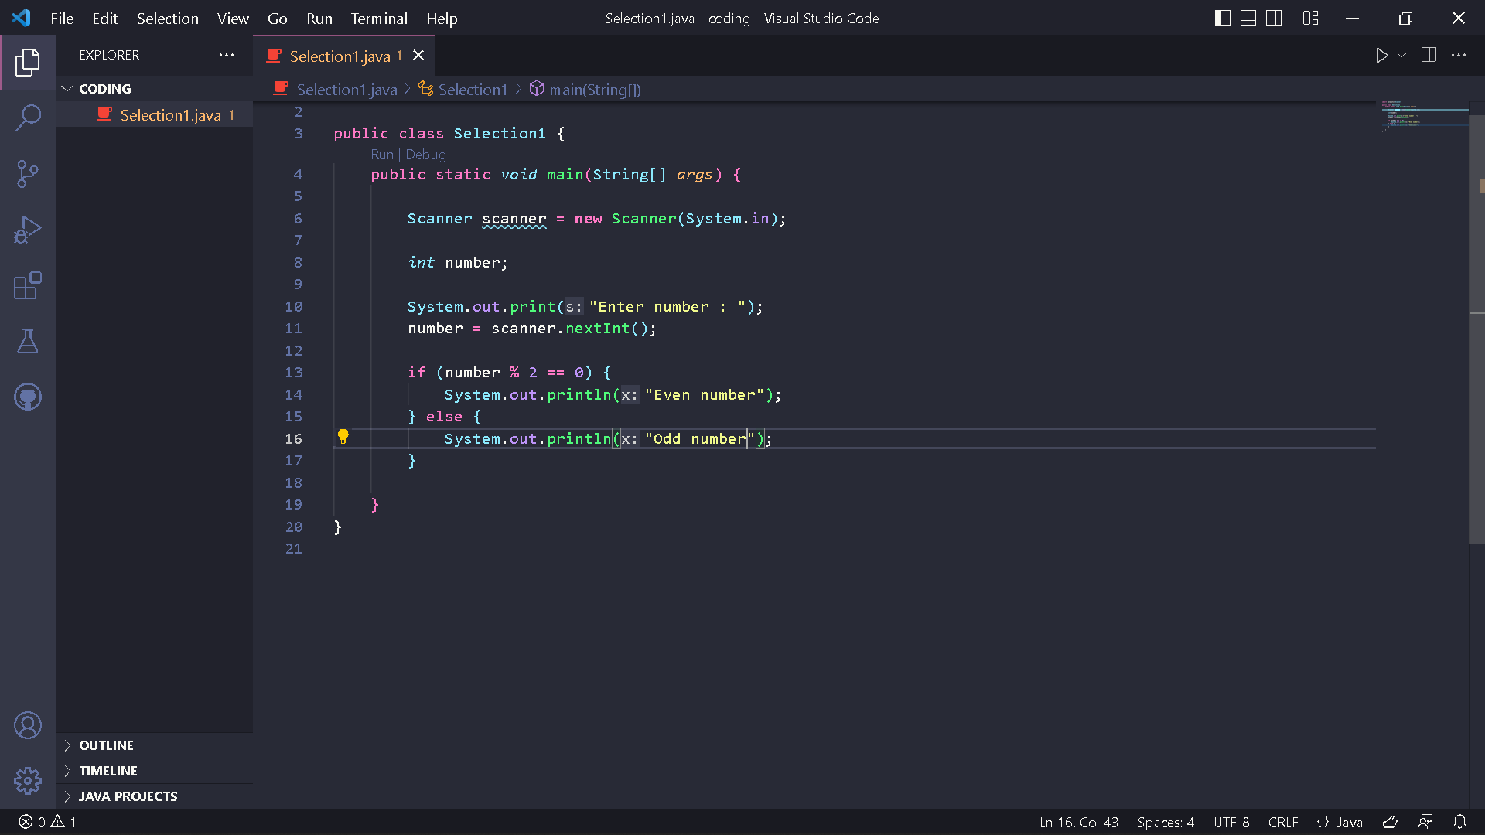

Result :

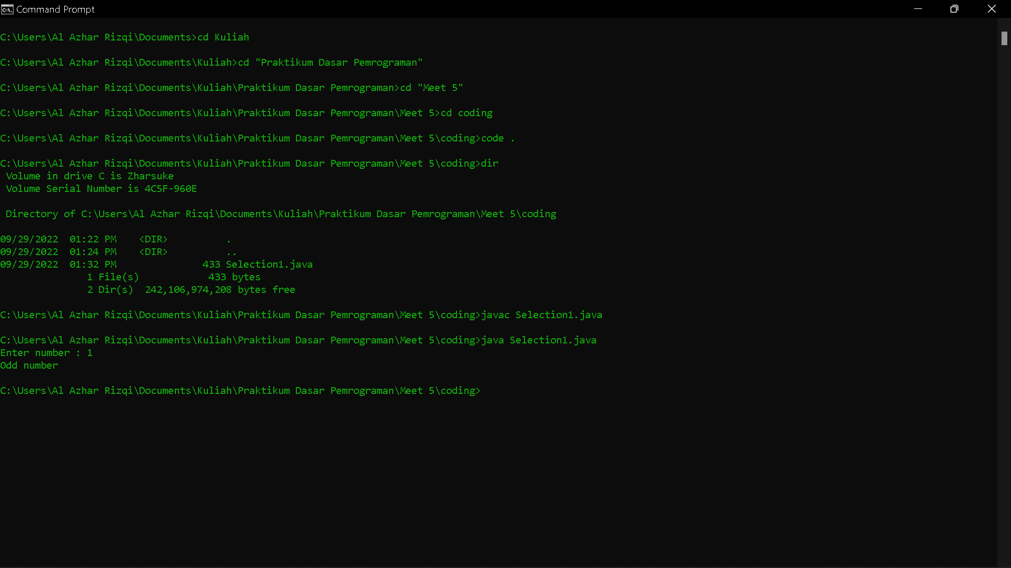

Questions!

1. Modify the program in its selection structure so that it becomes as follows:

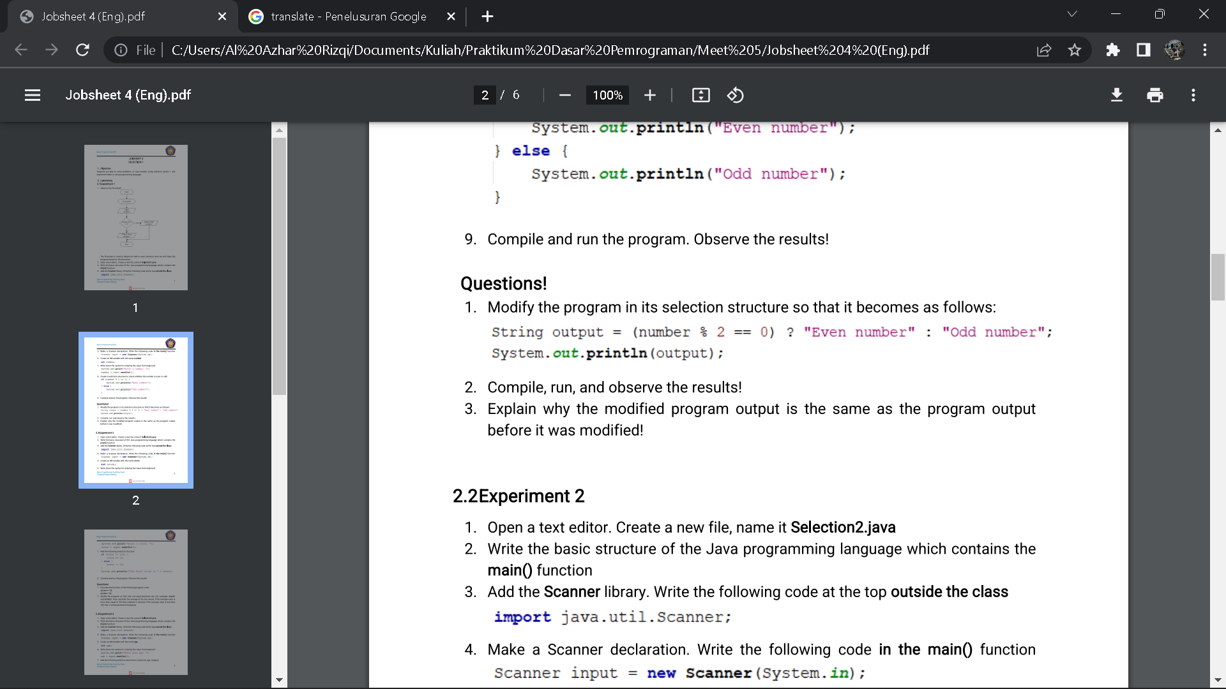

2. Compile, run, and observe the results!

3. Explain why the modified program output is the same as the program out put before it was modified!

Answer

1. Code :

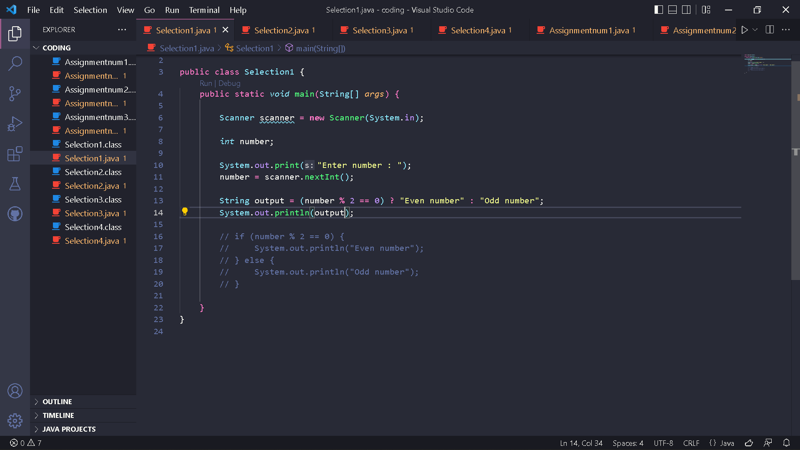

1. Result :

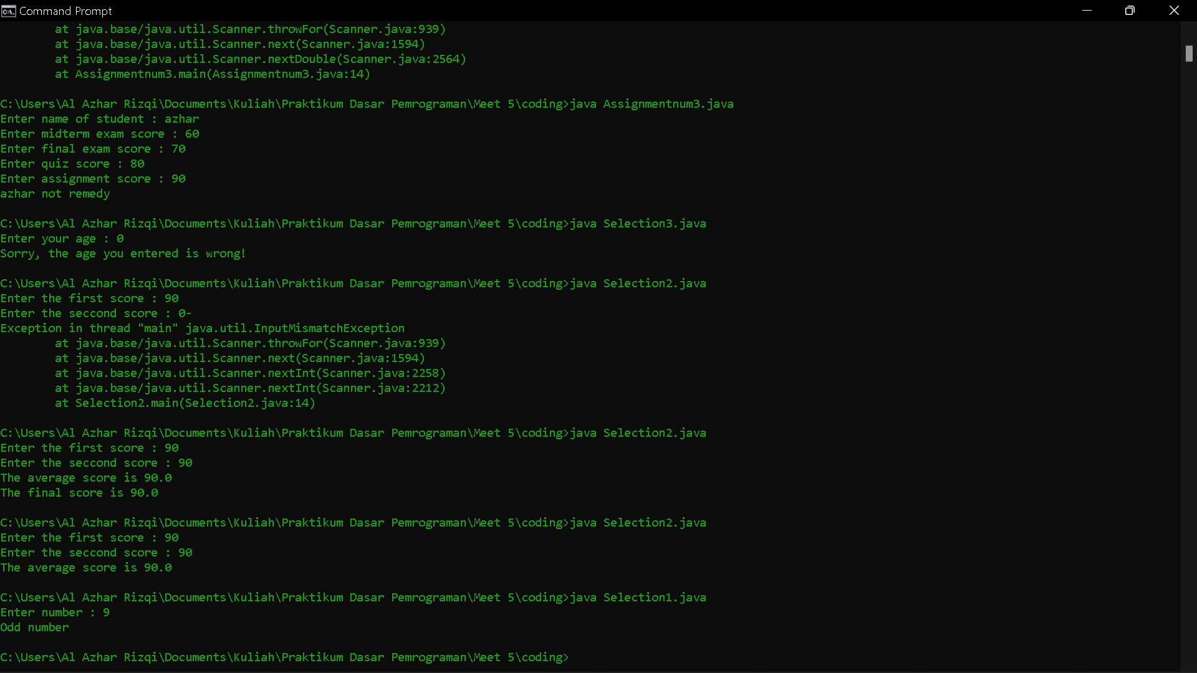

1. The code above using ternary operator. The ternary operator is the same as the if else statement but condensed into one line only.

Experiment 2

1. Open a text editor. Create a new file, name it Selection2.java

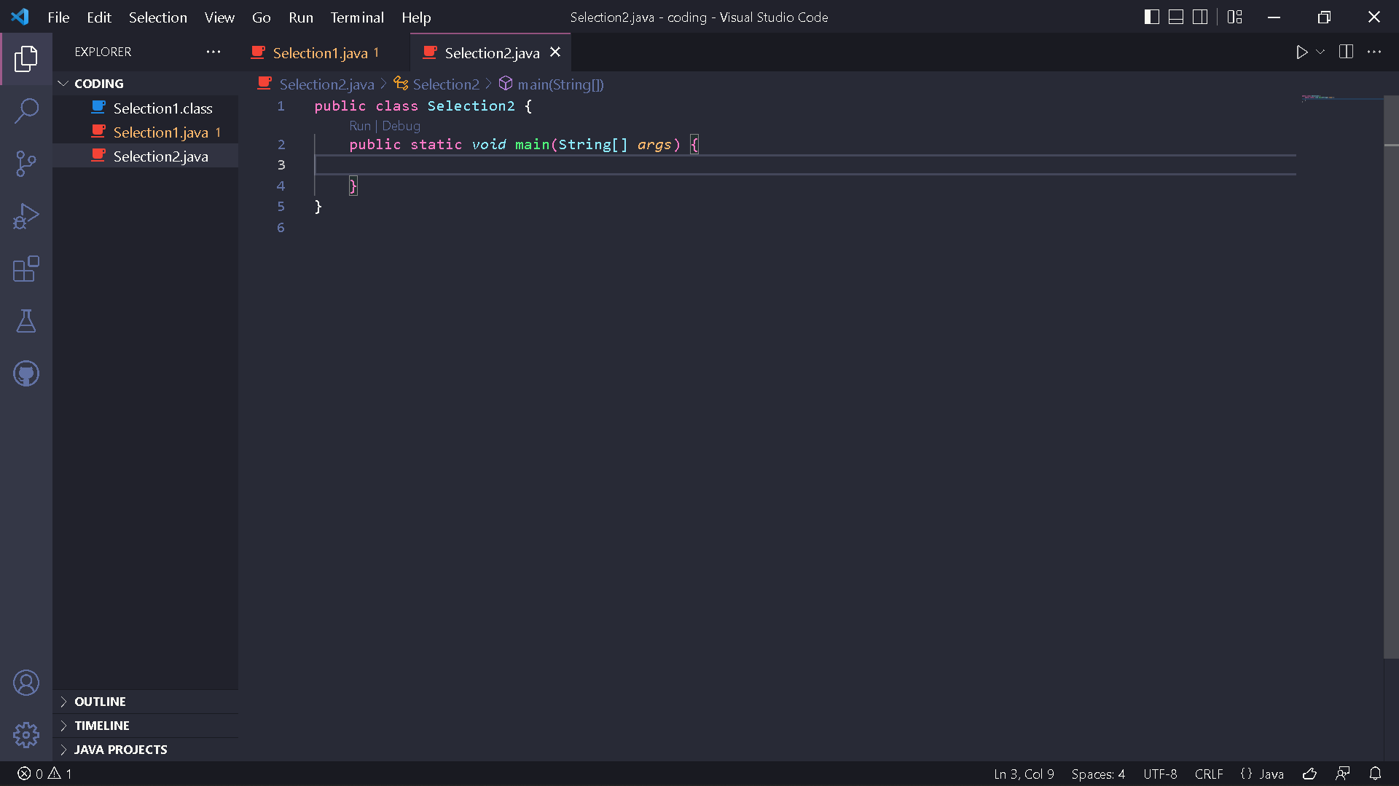

1. Write the basic structure of the Java programming language which contains the main() function



1. Add the Scanner library. Write the following code at the top outside the class



1. Make a Scanner declaration. Write the following code in the main() function



1. Create an int variable with the name score

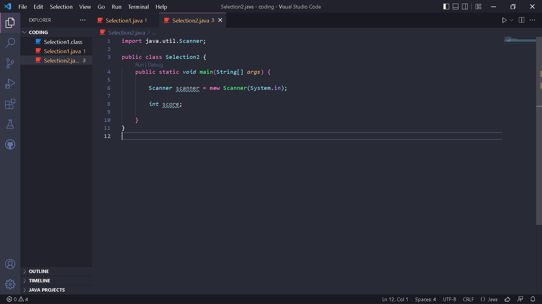

1. Write down the syntax for entering the value from keyboard

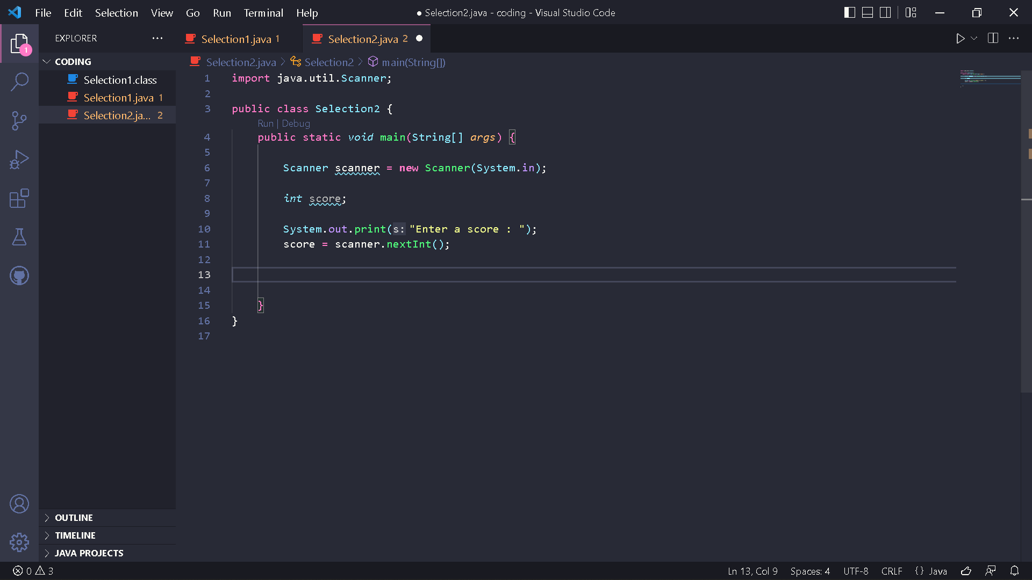

1. Add the following selection structure

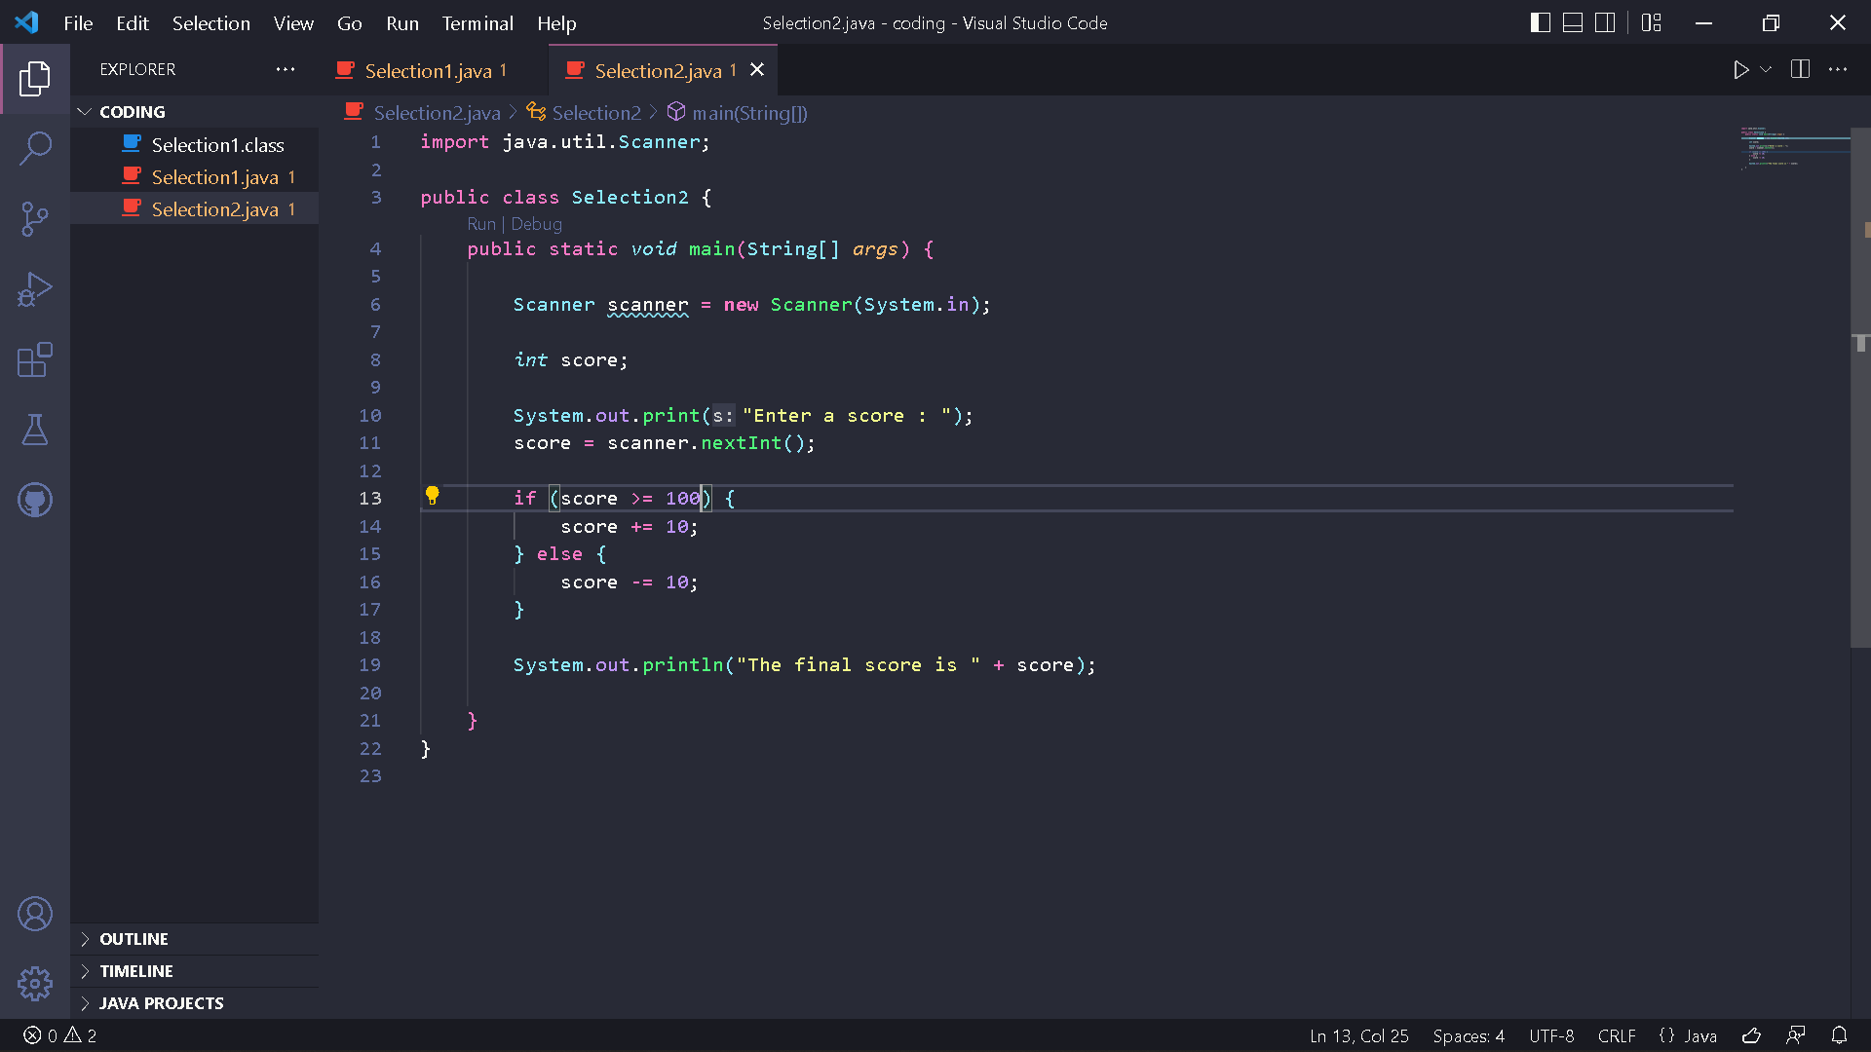

1. Compile and run the program. Observe the results!

Code :



Result :

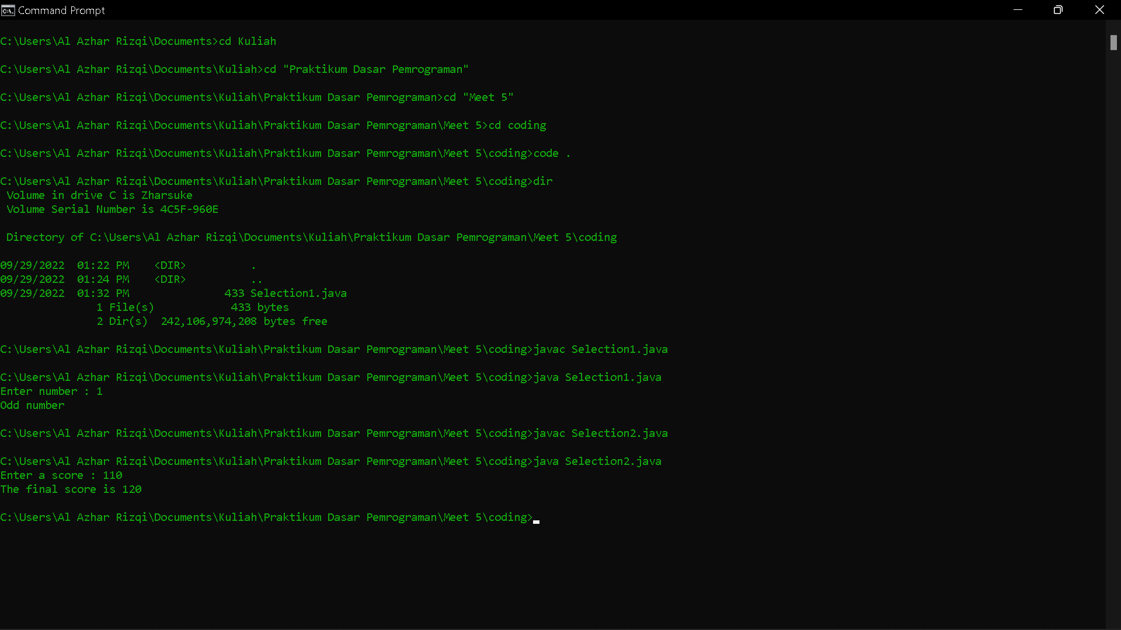

Questions!

1. Describe the function of the following program code: score += 10; score -= 10;

2. Modify the program so that only one input becomes two (for example: score1and score2). Then calculate the average of the two values, if the average value is more than equal to 100 then subtract 5, whereas if the average value is lessthan100 then it will be printed immediately!

Answer

1. The function of score += 10 is score plus equals 10, and then function of score -= 10 is score subtract equals 10.
2. Code :

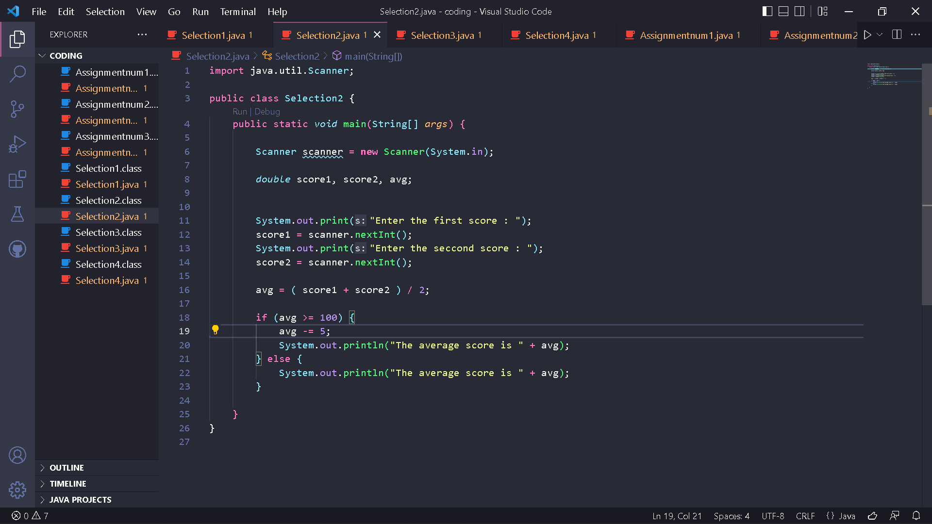

Result :

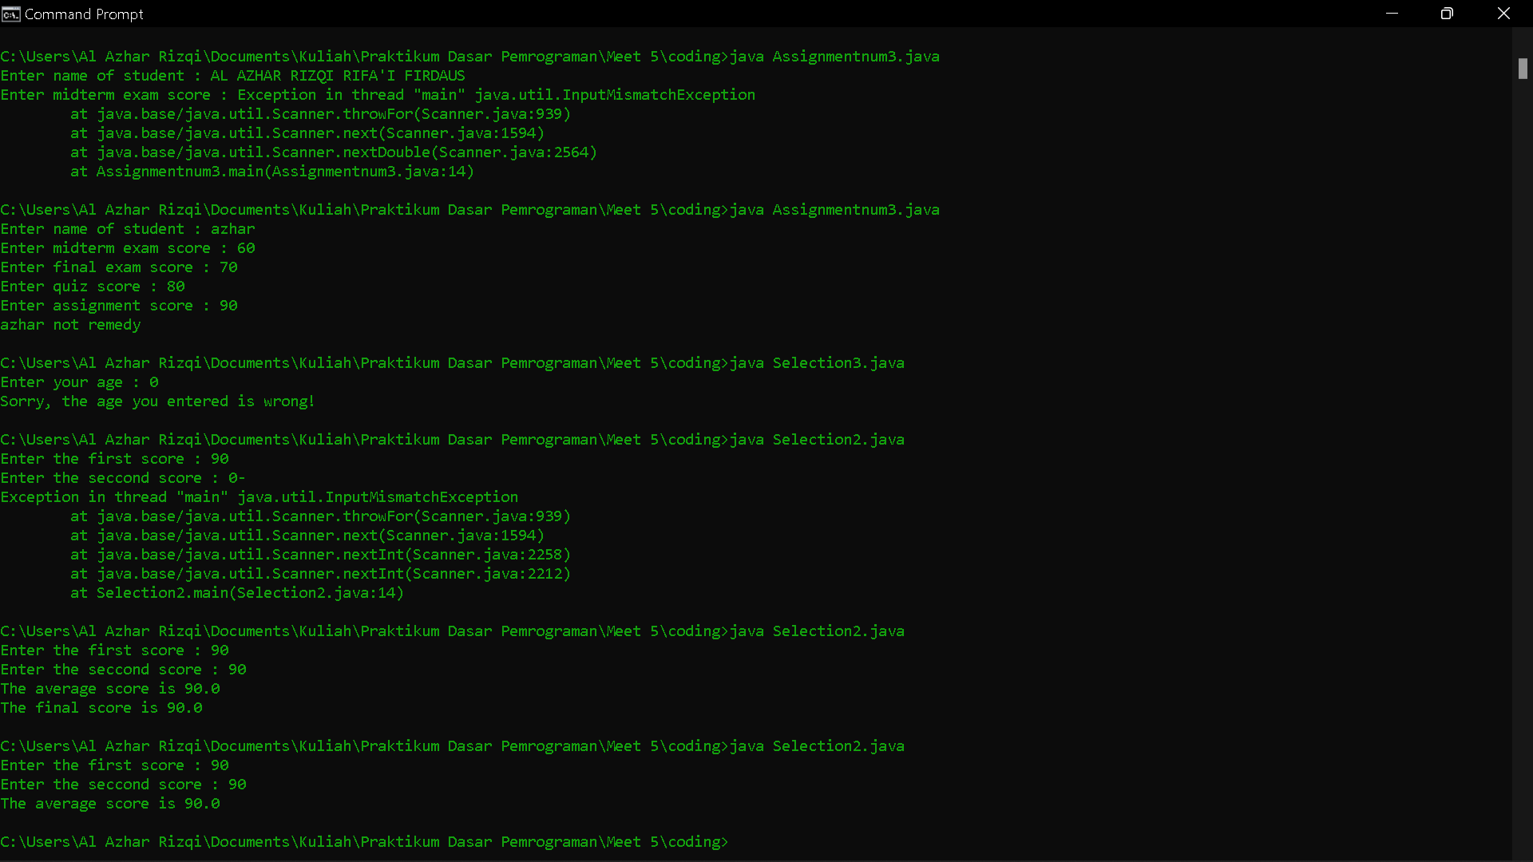

Experiment 3

1. Open a text editor. Create a new file, name it Selection3.java

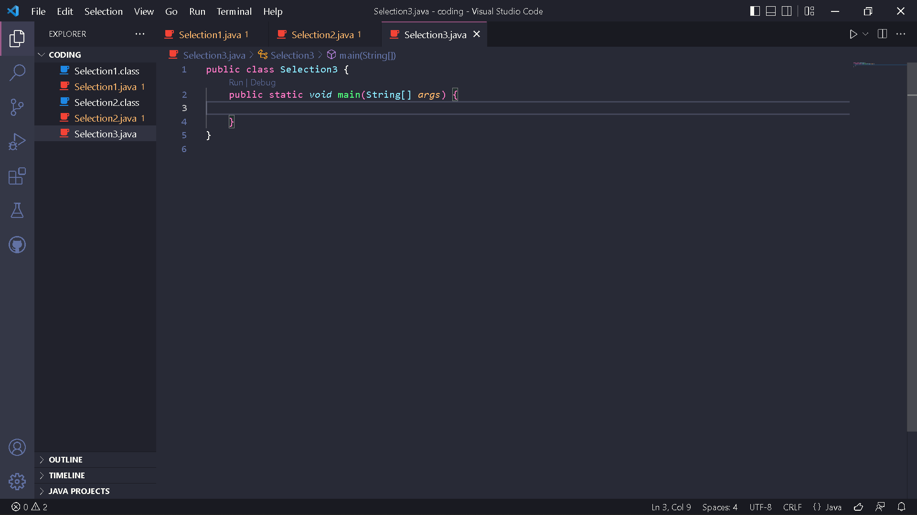

1. Write the basic structure of the Java programming language which containsthemain() function

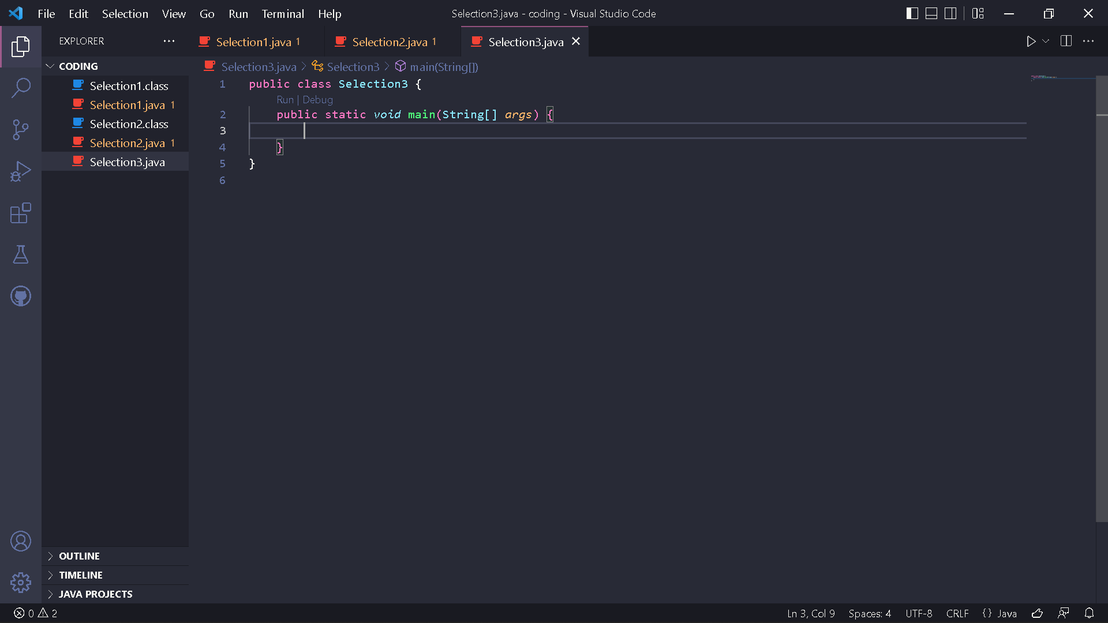

1. Add the Scanner library. Write the following code at the top outside the class



1. Make a Scanner declaration. Write the following code in the main() function



1. Create an int variable with the name age

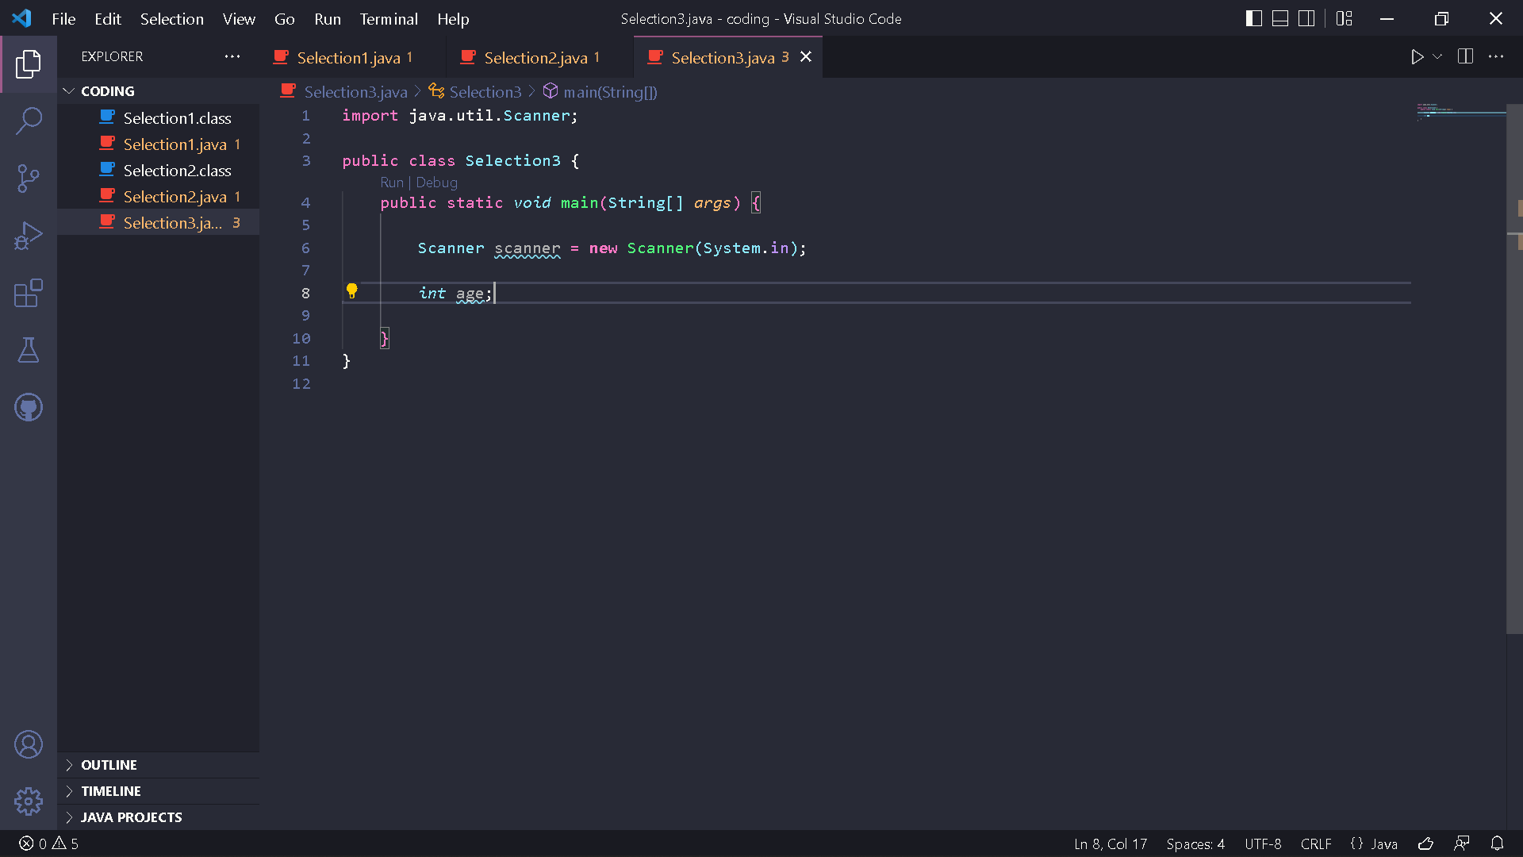

1. Write down the syntax for entering the value from keyboard

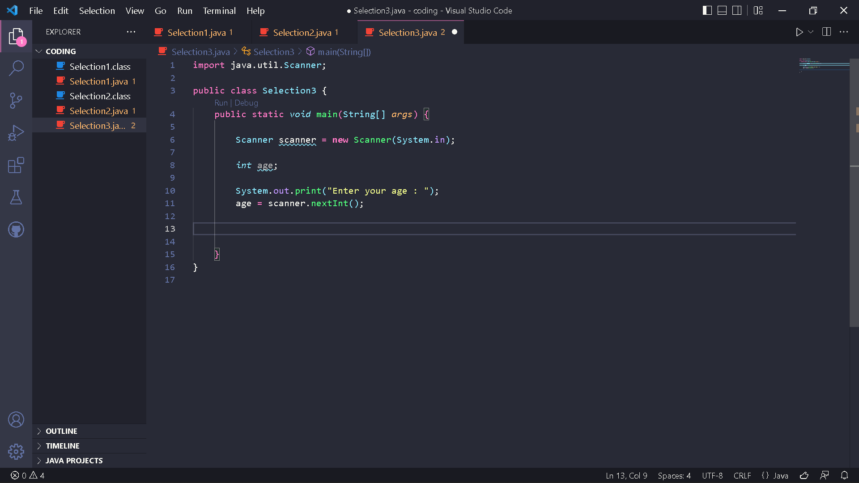

1. Add the following selection structure to check the age category

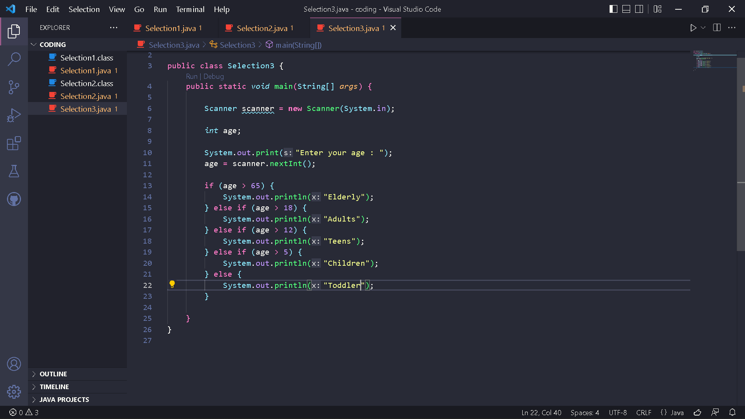

1. Compile and run the program. Observe the results!

Code :

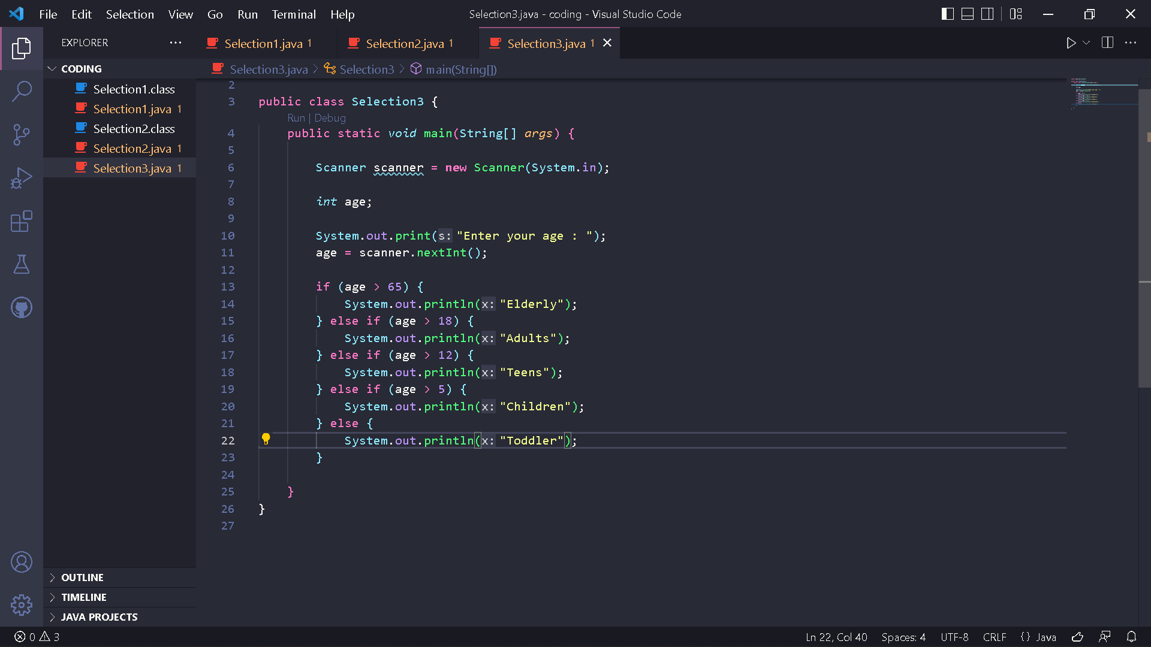

Result :

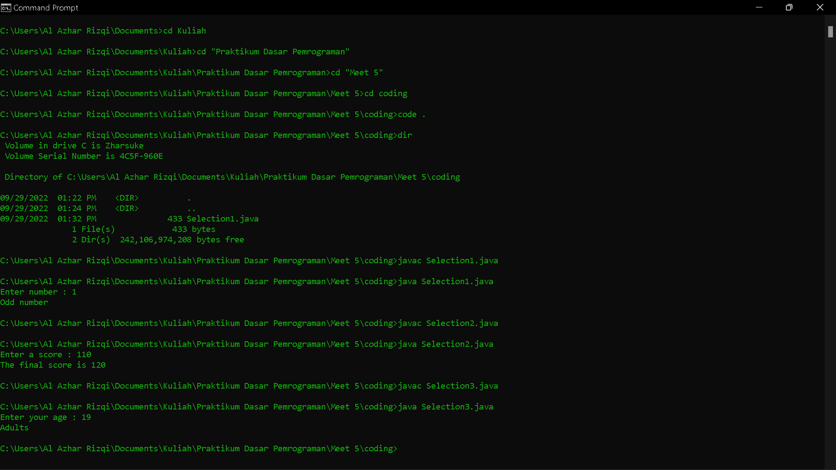

Questions!

1. How many conditions exist in experiment 3? Mention what the conditionsare!

2. Modify the program so that if the age entered is 0 years or less than0it will display the output "Sorry, the age you entered is wrong"!

Answer

1. There is 5 conditions. First if age > 65, second else if age > 18, third else if age > 12, fourth else if age > 5, and last else.
2. Code :

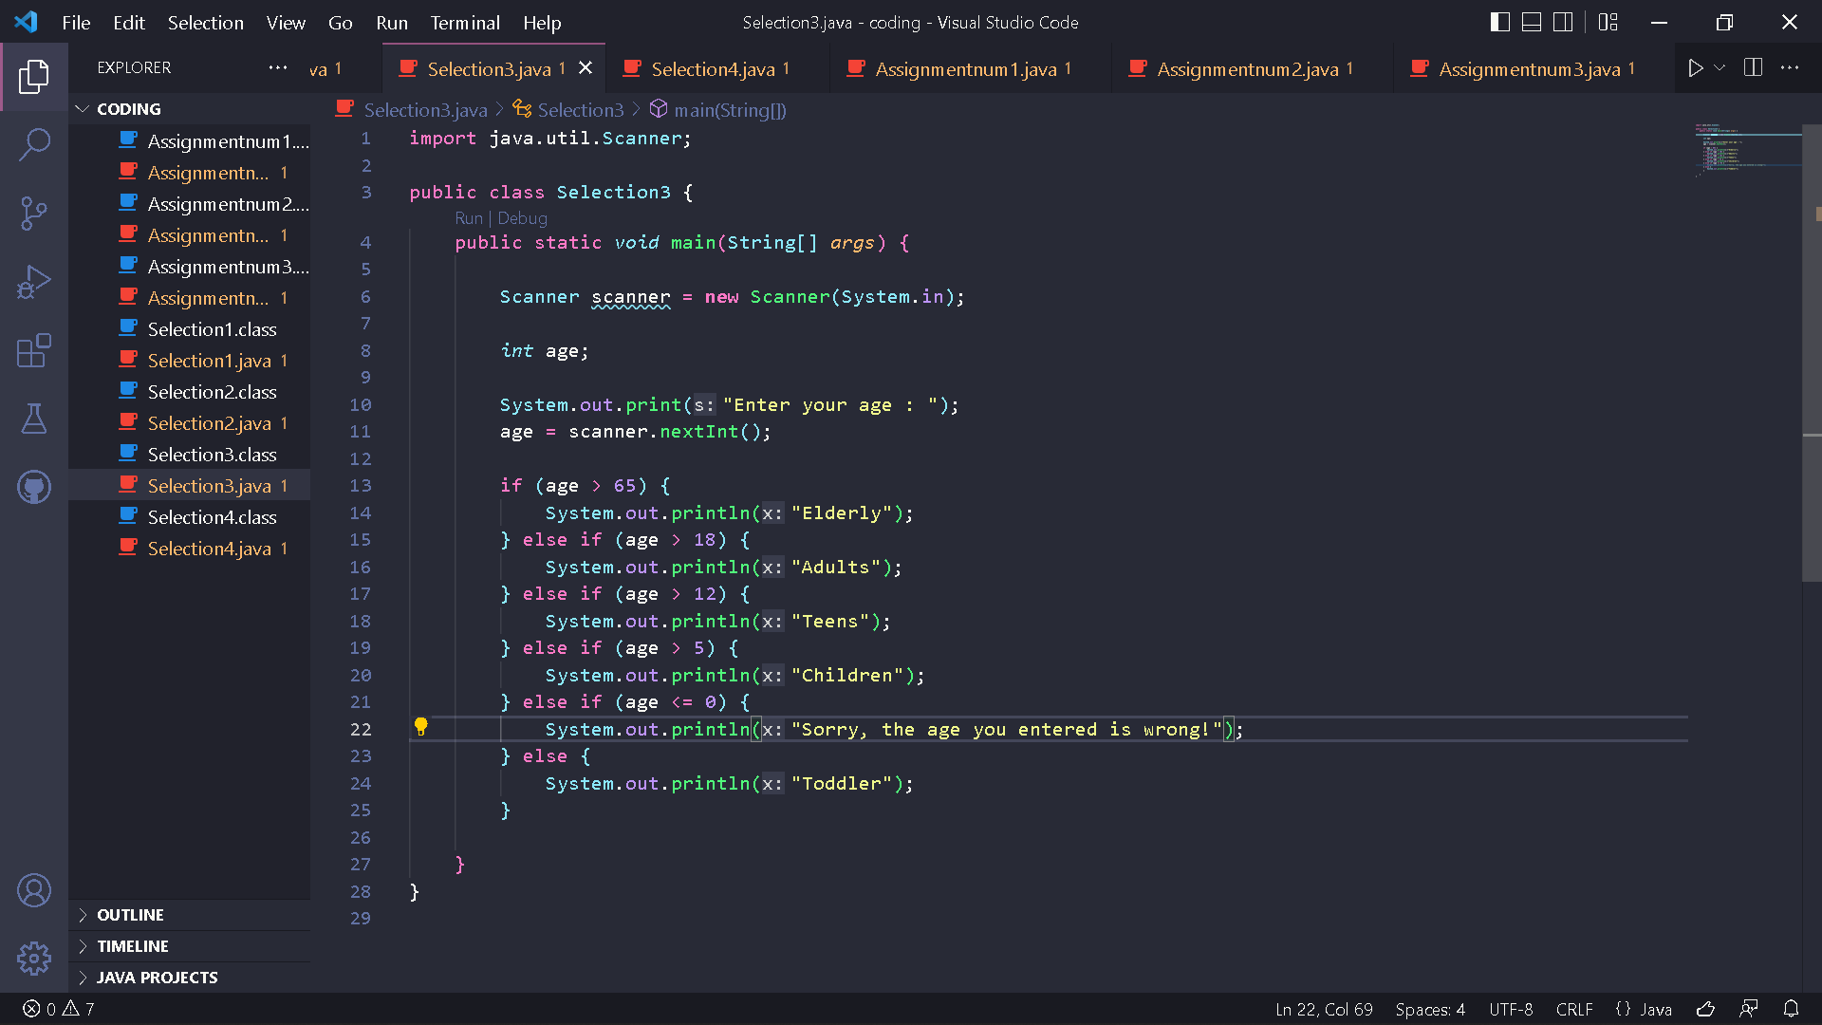

Result :

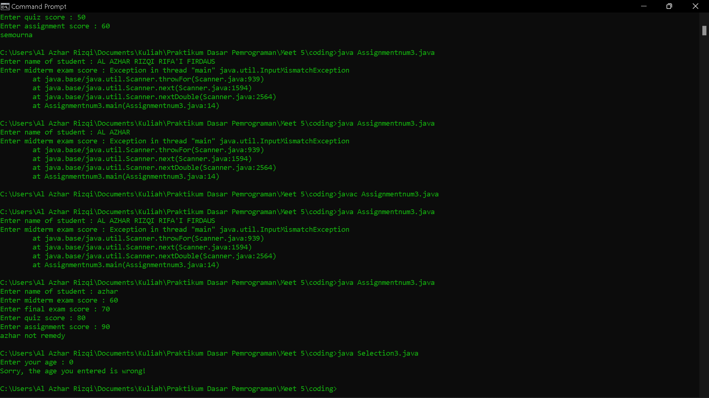

Experiment 4

1. Open a text editor. Create a new file, name it Selection4.java

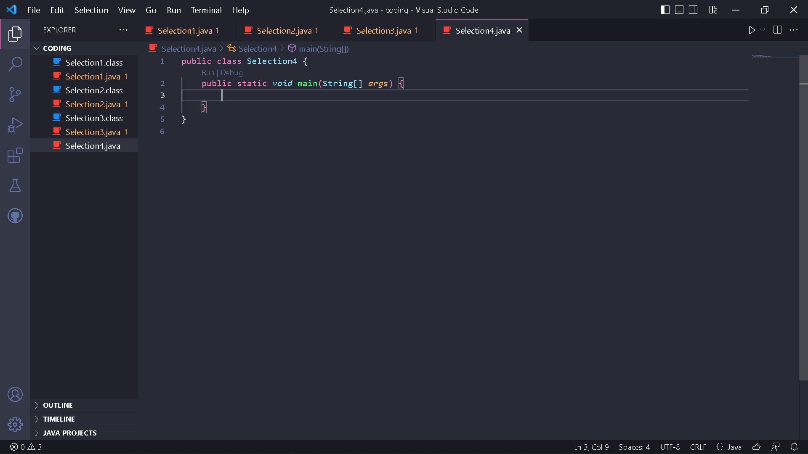

1. Write the basic structure of the Java programming language which containsthemain() function



1. Add the Scanner library. Write the following code at the top outside the class



1. Make a Scanner declaration. Write the following code in the main() function



1. Create the following variables

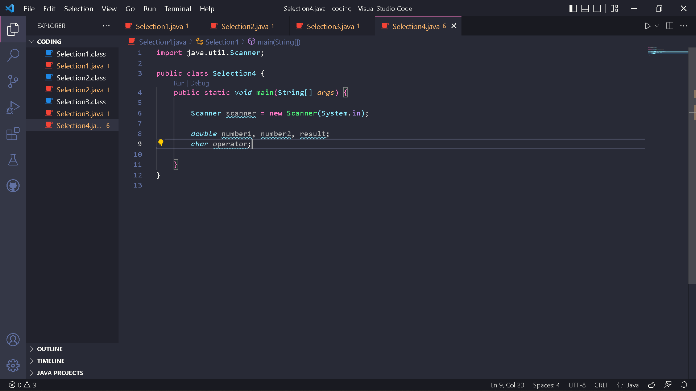

1. Write down the syntax for entering values from keyboard

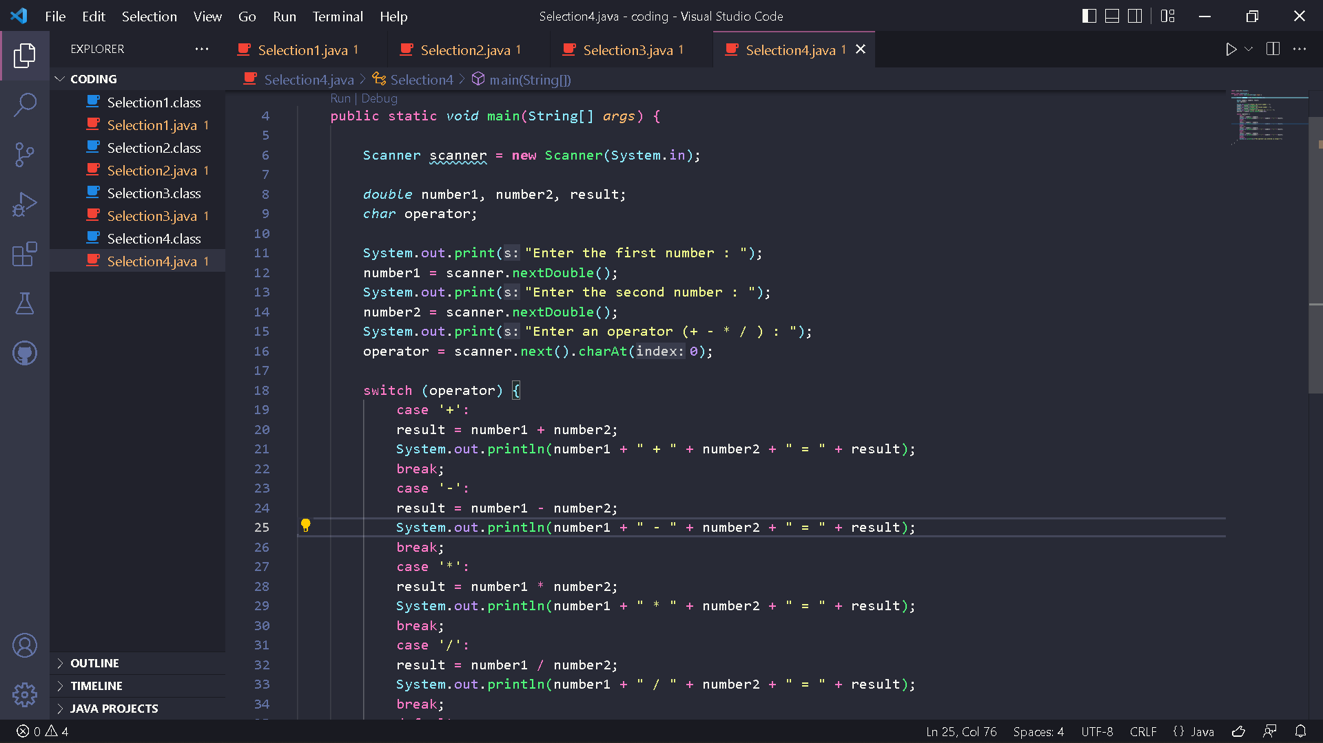

1. Add the following selection structure

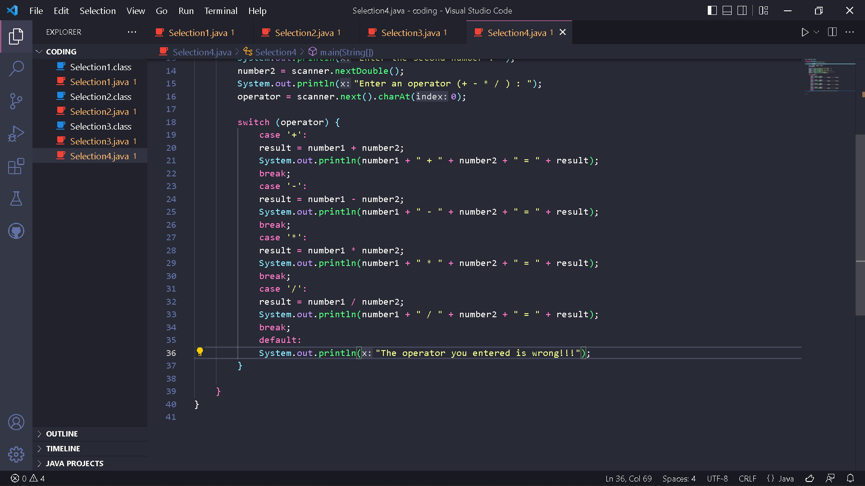

1. Compile and run the program. Observe the results!

Code :

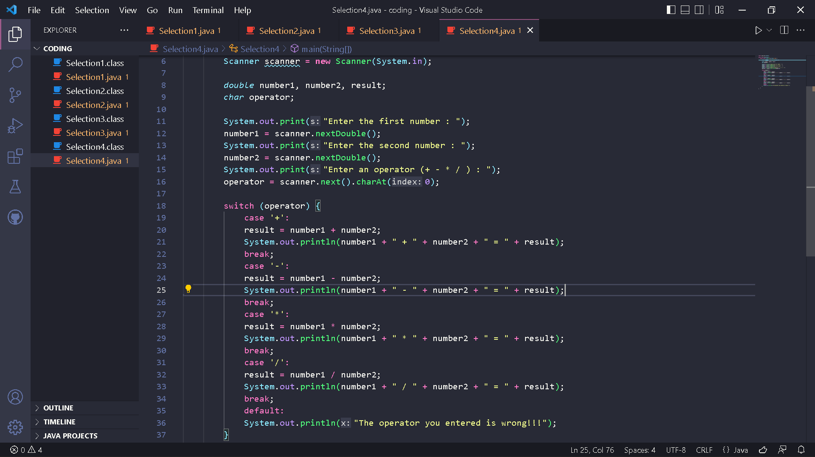

Result :

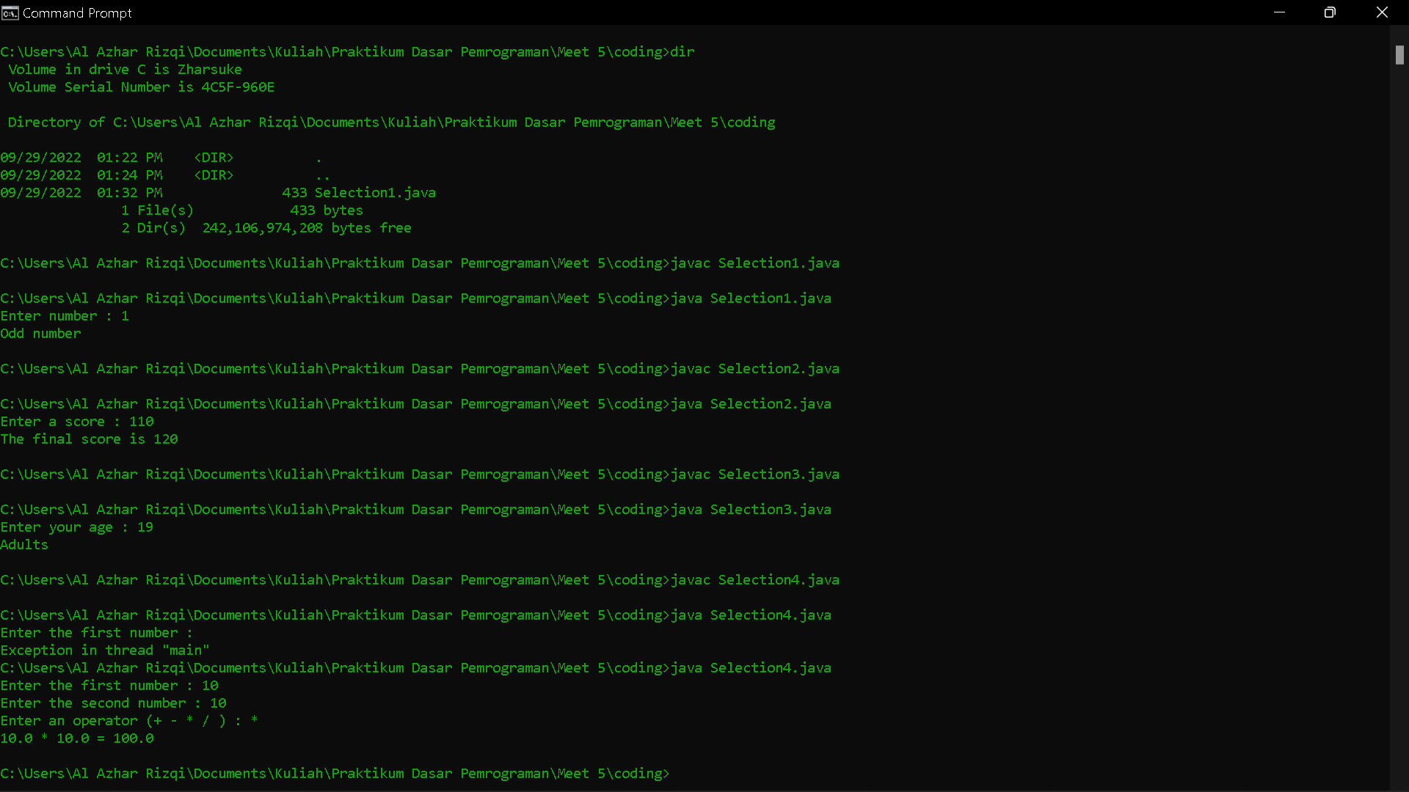

Questions!

1. Explain the function of break and default in experiment 4!

2. Explain the function of the following program code commands! operator = input.next().charAt(0);

Answer

1. The function of break is it breaks out of the switch block. And function of default is running code if there is no case match.
2. next() function returns the next token/word in the input as a string and charAt(0) function returns the first character in that string.